s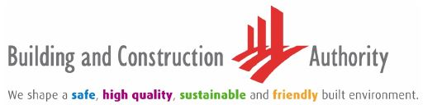

|  |  |
| --- | --- |
| BCA BC BMSC/CIR/2016/01  1 November 2016 | Building Plan & Management Group |
|  |  |

Chairman/ Secretary

MCST XXXX

Dear Sir/ Madam

**ELECTRONIC FILING OF ANNUAL GENERAL MEETING (AGM) INFORMATION OF MANAGEMENT CORPORATION**

**Aim**

This circular is to inform that, with effect from **2 January 2017**, Management Corporations (MCSTs) are required to file their AGM returns online through BCA’s Electronic Annual General Meeting (eAGM) System. Beyond the effective date, AGM returns filed in hardcopies will not be accepted.

**eAGM System for MCSTs**

2 The Building and Construction Authority (“BCA”) introduced the eAGM System in February 2009 to provide applicants with a simpler, faster and more cost-effective means to submit AGM returns online. This online system helped to improve the process of filing AGM returns by ensuring that mandatory fields are filled in accordingly before submission to BCA to avoid delay, allow MCSTs to receive instant acknowledgement from BCA when e-filed successfully and retrieve AGM information at any point of time.

**3 Simple Steps to use the eAGM System**

3 MCST only needs to go through 3 simple steps to submit AGM returns online.

(a) **Step 1**: Nominates An Authorised Person

Council needs to nominate and authorise a member or managing agent to e-File the AGM returns online. First time users can register for the access by filling up the attached nomination form and return it to BCA by post, fax or email. The nomination form is also available for downloading at the following link:

<https://www.bca.gov.sg/BMSMForms/bmsm_applnforms.html>.

(b) **Step 2**: Receipt of User ID and Password

Upon successful submission of the nomination form, BCA will issue the User ID and Password to the authorised person within 7 working days.

(c) **Step 3**: Login to the eAGM System

The authorised person is required to login to the eAGM System at <https://www.bca.gov.sg/bmsm_eservice/> using the **User ID and Password**. User is required to submit the Notice and Agenda of the AGM and key in AGM details. Upon successful submission, user can print out the receipt of acknowledgement.

**User Manual**

4 The User Manual is also available for downloading at the following link: <https://www.bca.gov.sg/bmsm_eservice/>.

**For Further Information and Clarification**

5 We have also prepared the Frequently Asked Questions (FAQs) for the eAGM System, which is enclosed for your reference. If you need further clarification on the filing of AGM returns, please contact «AREA_TSO» at Tel: «Tel»or «Email». Thank you.

Yours faithfully

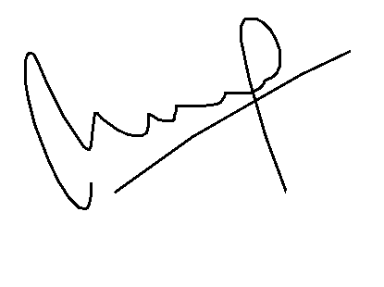

LOW EE PENG

for COMMISSIONER OF BUILDINGS

BUILDING MANAGEMENT DEPARTMENT